PARKINSON’S DISEASE DETECTION
A PROJECT REPORT

Submitted by

Rajat Gore (20BAI10184)
Divyanshu Chetan (20BAI10129)
Shivam Kabra (20BAI10298)
Divyansh Sahu (20BAI10363)

in partial fulfillment for the award of the degree
of

BACHELOR OF TECHNOLOGY

In

COMPUTING SCIENCE AND ENGINEERING WITH SPECIALIZATION IN ARTIFICAL INTELLIGENCE AND MACHINE LEARNING



SCHOOL OF COMPUTING SCIENCE AND ENGINEERING
VIT BHOPAL UNIVERSITY
KOTHRIKALAN, SEHORE
MADHYA PRADESH - 466114

APRIL, 2022

VIT BHOPAL UNIVERSITY, KOTHRIKALAN, SEHORE
MADHYA PRADESH – 466114

BONAFIDE CERTIFICATE

Certified that this project report titled “……PARKINSON’S DISEASE DETECTION ……………..” is the bonafide work of “…DIVYANSH SAHU (20BAI10363), DIVYANSHU CHETAN (20BAI10129), RAJAT GORE (20BAI10184), SHIVAM KABRA (20BAI10298)” who carried out the project work under my supervision. Certified further that to the best of my knowledge the work reported at this time does not form part of any other project/research work based on which a degree or award was conferred on an earlier occasion on this or any other candidate.

PROGRAM CHAIR PROJECT GUIDE
Dr S Sountharrajan, Associate Professor Dr Rajeev Goyal, Assistant Professor
School of Computer Science and Engineering School of Computer Science and Engineering
VIT BHOPAL UNIVERSITY VIT BHOPAL UNIVERSITY

The Project Exhibition I Examination is held on ______22.04.22_________

ACKNOWLEDGEMENT

First and foremost I would like to thank the Lord Almighty for His presence and immense blessings throughout the project work.
I wish to express my heartfelt gratitude to Dr S Sountharrajan, Head of the Department, School of Aeronautical Science for much of his valuable support encouragement in carrying out this work.
I would like to thank my internal guide Dr. Rajeev Goyal, for continually guiding and actively participating in my project, giving valuable suggestions to complete the project work.
I would like to thank all the technical and teaching staff of the School of Aeronautical Science, who extended directly or indirectly all support.
Last, but not least, I am deeply indebted to my parents who have been the greatest support while I worked day and night for the project to make it a success.

ABSTRACT

The number of persons affected by Parkinson's disease (PD) is increasing as the world's population ages. Unfortunately, in impoverished nations, efficient and early PD detection is difficult due to a lack of resources and awareness. Furthermore, the symptoms of all PD patients are neither the same, nor do they all appear at the same time during the illness. As a result, the goal of this research is to combine multiple symptoms (rest tremor and voice degradation) by collecting data and detecting Parkinson's disease using machine learning system for telemonitoring PD patients in developing nations.

TABLE OF CONTENT
 | List of Abbreviations  List of Figures and Graphs  List of Tables  Abstract | iii  iv  v  vi
1 | CHAPTER-1:  PROJECT DESCRIPTION AND OUTLINE  Introduction  1.2 Motivation for the work  1.3 [About Introduction to the project  including techniques]  1.5 Problem Statement  1.6 Objective of the work  1.7 Organization of the project  1.8 Summary | 1  .  .  .
2 | CHAPTER-2:  RELATED WORK INVESTIGATION  2.1 Introduction  2.2 <Core area of the project>  2.3 Existing Approaches/Methods  2.3.1 Approaches/Methods -1  2.3.2 Approaches/Methods -2  2.3.3 Approaches/Methods -3  2.4 <Pros and cons of the stated Approaches/Methods >  2.5 Issues/observations from investigation  2.6 Summary
3 | CHAPTER-3:  REQUIREMENT ARTIFACTS  3.1 Introduction  3.2 Hardware and Software requirements  3.3 Specific Project requirements  3.3.1 Data requirement  3.3.2 Functions requirement  3.3.3 Performance and security requirement  3.3.4 Look and Feel Requirements  3.3.5 ………  3.4 Summary
4 | CHAPTER-4:  DESIGN METHODOLOGY AND ITS NOVELTY  4.1 Methodology and goal  4.2 Functional modules design and analysis  4.3 Software Architectural designs  4.4 Subsystem services  4.5 User Interface designs  4.5 ………………..  4.6 Summary
5 | CHAPTER-5:  TECHNICAL IMPLEMENTATION & ANALYSIS  5.1 Outline  5.2 Technical coding and code solutions  5.3 Working Layout of Forms  5.4 Prototype submission  5.5 Test and validation  5.6 Performance Analysis(Graphs/Charts)  5.7 Summary
6 | CHAPTER-6:  PROJECT OUTCOME AND APPLICABILITY  6.1 Outline  6.2 key implementations outlines of the System  6.3 Significant project outcomes  6.4 Project applicability on Real-world applications  6.4 Inference
7 | CHAPTER-7:  CONCLUSIONS AND RECOMMENDATION  7.1 Outline  7.2 Limitation/Constraints of the System  7.3 Future Enhancements  7.4 Inference

Appendix A

Appendix B

References

Note: List of References should be written as per IEEE/Springer reference format. (Specimen attached)

CHAPTER-1:
PROJECT DESCRIPTION AND OUTLINE

1.1 Introduction
Parkinson Disease is a brain neurological disorder. It leads to shaking of the body, hands and provides stiffness to the body. No proper cure or treatment is available yet at the advanced stage.
Treatment is possible only when done at the early or onset of the disease. These will not only reduce the cost of the disease but will also possibly save a life.
Parkinson’s disease is a progressive disorder of the central nervous system affecting movement and inducing tremors and stiffness. It has 5 stages to it and affects more than 1 million individuals every year in India. This is chronic and has no cure yet. It is a neurodegenerative disorder affecting dopamine-producing neurons in the brain.
Most methods available can detect Parkinson in an advanced stage; which means loss of approx.. 60% dopamine in basal ganglia and is responsible for controlling the movement of the body with a small amount of dopamine. More than 145,000 people have been found alone suffering in the U.K and in India, almost one million population suffers from this disease and it’s spreading fast in the entire world.

1.2 Motivation for the work
Parkinson’s Disease is a degenerative neurological condition that affects approximately 10 million people globally. Because there is currently no cure, there is a strong motivation for research into improved and automated diagnostic procedures. Using M.L. algorithms, a computer can effectively learn to diagnose Parkinson’s disease in a patient with high accuracy, precision, and recall across the data of over 2800 patients. Using similar techniques, I further determine that the most predictive medical tests relate to tremors observed in patients.

1.3 About Introduction to the project including techniques
Machine learning techniques are being increasingly applied in the healthcare sector. As its name implies, machine learning allows for a computer program to learn and extract meaningful representation from data in a semi-automatic manner. For the diagnosis of PD, machine learning models have been applied to a multitude of data modalities, including handwritten patterns.
This proposed system receives rest tremor and vowel phonation data The data are primarily collected from diagnosed PD patients and healthy people for building and optimizing machine learning models that exhibit higher performance. After that, data from newly suspected PD patients are collected, and the trained algorithms are evaluated to detect PD, with the help of these algorithms:-
XG BOOST ALGORITHM: XGBoost is a new Machine Learning algorithm designed with speed and performance in mind. XGBoost stands for Xtreme Gradient Boosting and is based on decision trees.

KNN Algorithms: K-Nearest Neighbors (KNN) algorithm, is one of the most powerful utilized algorithms of machine learning that is widely used both for regression as well as classification tasks.

Support Vector Machines: It is a supervised machine algorithm used. It sorts the data in one out of two categories and displays the output with the margin between the two as far as possible.

Random Forest Algorithm: Random forests are an ensemble version of many choice bushes, wherein each tree will specialize its focus on a specific feature while maintaining a top-level view of all capabilities
1.5 Problem Statement
We have used machine learning algorithms like XGBoost, KNN, SVMs, and Random Forest Algorithm to check which is the best algorithm for detection of the onset of disease.
1.6 Objective of the work
To build a model to accurately detect the presence of Parkinson’s disease in an individual.
1.7 Organization of the project
We have used various machine learning algorithms to check which is the best algorithm for detection of the onset of disease.
Then, build a model to accurately detect the presence of Parkinson’s disease in an individual.
In this Python machine learning project, we have used the Python libraries like scikit-learn, numpy and pandas
And machine learning algorithms such as:
- XG-boost
- KNN algorithm
- Support vector machines (SVM’S)
- Random Forest algorithm,

We have build a model using 3 classification algorithms. We load the data, get the features and labels, scale the features, then split the dataset, build a classifier, and then calculate the accuracy of our model.
1.8 Summary
In this Python machine learning project, we learned to detect the presence of Parkinson’s Disease in individuals using various factors. We used different classification algorithms for this and made use of the sklearn library to prepare the dataset. This gives us an accuracy of 94.8% for testing data, which is great considering the number of lines of code in this python project.

CHAPTER-2:
RELATED WORK INVESTIGATION

2.1 Introduction
Before committing to the project several ground works should be done, so we analyzed many papers regarding the detection of Parkinson’s disease. The papers we have taken will be in the different years up to the present year and would have used the recent and latest technologies.
The main goal is to get more accuracy than the previous works the below passages will describe the past prediction works done by the various researchers and it will be helpful to implement the corresponding project.
The most common method for the diagnosis of PD symptoms is using the Unified PD Rating Scale (UPDRS), and the motor examinations are being done on the subscale of 0 (absence) to 4.
2.2 Core area of the project
The project investigates the processing signals for detecting Parkinson’s disease. This disease is one of the neurological disorders that affect people in the world most. The approach evaluates the use of eighteen feature extraction techniques and four machine learning methods to classify data obtained from sustained phonation and speech tasks.
In the study conducted by researchers, acceleration signals for detection of PD has been investigated for its convenience. effective and efficient diagnosis system using k-nearest neighbor (KNN) for Parkinson’s disease (PD) diagnosis. The proposed KNN-based system is compared with the support vector machines (SVM) based approaches. In order to further improve the diagnosis accuracy for detection of PD, the principle component analysis was employed to construct the most discriminative new feature sets on which the optimal KNN model was constructed. The effectiveness of the proposed system has been rigorously estimated on a PD data set in terms of classification accuracy, sensitivity, specificity and the area under the receiver operating characteristic (ROC) curve (AUC). Experimental results have demonstrated that the KNN-based system greatly outperforms SVM-based approaches and other methods in the literature. The best classification accuracy (94.87%) obtained by the KNN-based system using a 10-fold cross validation method can ensure a reliable diagnostic model for detection of PD. Promisingly, the proposed system might serve as a new candidate of powerful tools for diagnosing PD with excellent performance.
2.3 Existing Approaches/Methods
2.3.1 Support Vector Machine
Algorithm for the analysis of classification and regression is the support vector machine. It is a supervised machine algorithm used. Image classification and hand-written recognition are where the support vector machine comes to hand used. It sorts the data in one out of two categories and displays the output with the margin between the two as far as possible.
Support Vector Machine(SVM) is a supervised machine learning algorithm used for both classification and regression. Though we say regression problems as well its best suited for classification. The objective of SVM algorithm is to find a hyperplane in an N-dimensional space that distinctly classifies the data points.

2.3.2 KNN
K-Nearest Neighbour is one of the simplest Machine Learning algorithms based on Supervised Learning technique.
K-NN algorithm assumes the similarity between the new case/data and available cases and put the new case into the category that is most similar to the available categories.
K-NN algorithm stores all the available data and classifies a new data point based on the similarity. This means when new data appears then it can be easily classified into a well suite category by using K- NN algorithm.
K-NN algorithm can be used for Regression as well as for Classification but mostly it is used for the Classification problems.

2.3.3 Random forests
Random forest is a Supervised Machine Learning Algorithm that is used widely in Classification and Regression problems. It builds decision trees on different samples and takes their majority vote for classification and average in case of regression.

One of the most important features of the Random Forest Algorithm is that it can handle the data set containing continuous variables as in the case of regression and categorical variables as in the case of classification. It performs better results for classification problems.
2.4 Pros and cons of the stated Approaches/Methods
i. SVM
Pros:
- It works really well with a clear margin of separation
- It is effective in high dimensional spaces.
- It is effective in cases where the number of dimensions is greater than the number of samples.
- It uses a subset of training points in the decision function (called support vectors), so it is also memory efficient.
Cons:
- It doesn’t perform well when we have large data set because the required training time is higher
- It also doesn’t perform very well, when the data set has more noise i.e. target classes are overlapping
- SVM doesn’t directly provide probability estimates, these are calculated using an expensive five-fold cross-validation. It is included in the related SVC method of Python scikit-learn library.

ii. KNN
pros:
- K-NN is pretty intuitive and simple: K-NN algorithm is very simple to understand and equally easy to implement. To classify the new data point K-NN algorithm reads through whole dataset to find out K nearest neighbors.
- K-NN has no assumptions: K-NN is a non-parametric algorithm which means there are assumptions to be met to implement K-NN. Parametric models like linear regression has lots of assumptions to be met by data before it can be implemented which is not the case with K-NN.
- No Training Step: K-NN does not explicitly build any model, it simply tags the new data entry based learning from historical data. New data entry would be tagged with majority class in the nearest neighbor.
- It constantly evolves: Given it’s an instance-based learning; k-NN is a memory-based approach. The classifier immediately adapts as we collect new training data. It allows the algorithm to respond quickly to changes in the input during real-time use.
- Very easy to implement for multi-class problem: Most of the classifier algorithms are easy to implement for binary problems and needs effort to implement for multi class whereas K-NN adjust to multi class without any extra efforts.
- Can be used both for Classification and Regression: One of the biggest advantages of K-NN is that K-NN can be used both for classification and regression problems.
- One Hyper Parameter: K-NN might take some time while selecting the first hyper parameter but after that rest of the parameters are aligned to it.
- Variety of distance criteria to be choose from: K-NN algorithm gives user the flexibility to choose distance while building K-NN model.
  - Euclidean Distance
  - Hamming Distance
  - Manhattan Distance
  - Minkowski Distance

Cons:
- K-NN slow algorithm: K-NN might be very easy to implement but as dataset grows efficiency or speed of algorithm declines very fast.
- Curse of Dimensionality: KNN works well with small number of input variables but as the numbers of variables grow K-NN algorithm struggles to predict the output of new data point.
- K-NN needs homogeneous features: If you decide to build k-NN using a common distance, like Euclidean or Manhattan distances, it is completely necessary that features have the same scale, since absolute differences in features weight the same, i.e., a given distance in feature 1 must means the same for feature 2.
iii. Random Forest
Pros: Random Forests can be used for both classification and regression tasks. Random Forests work well with both categorical and numerical data. No scaling or transformation of variables is usually necessary. Random Forests implicitly perform feature selection and generate uncorrelated decision trees. It does this by choosing a random set of features to build each decision tree. This also makes it a great model when you must work with a high number of features in the data.

Cons: Random Forests are not easily interpretable. They provide feature importance, but it does not provide complete visibility into the coefficients as linear regression. Random Forests can be computationally intensive for large datasets. Random forest is like a black box algorithm, you have very little control over what the model does.

2.5 Issues/observations from investigation
The highest accuracy in PD detection using KNN was 94.87% and other algorithms like SVM- 87.12% & RandomForest-87.17%. In both cases, k-nearest neighbours (kNN) gave the highest accuracy over support vector machine (SVM) and Random Forest. The application of maximum relevance minimum redundancy (MRMR) feature selection method showed that by selecting different feature sets based on the patient’s gender, we could improve the detection accuracy.
This study’s novelty is the application of ensemble averaging on the combined decisions generated from the analysis of voice and tremor data.
2.6 Summary
In this Python machine learning project, we learned to detect the presence of Parkinson’s Disease in individuals using various factors. We got highest accuracy with KNN classification algorithm for this and made use of the sklearn library to prepare the dataset.

CHAPTER-3:
REQUIREMENT ARTIFACTS
3.1 Introduction
A requirement describes a condition or capability to which a system must conform. There is a need of various Hardware and Software requirements for successful run of the project.
3.2 Hardware and Software requirements
- HARDWARE REQUIREMENTS
(PREFERABLE): INTERNET CONNECTIVITY
- 8GB-16GB RAM
- 4GB-6GB Graphics card (NVIDIA GPU)
- 1TB-2TB Hard disk AND 500GB -1TB SSD
- 8th generation (Intel Core i7 processor)
SOFTWARE REQUIREMENTS –
- Jupyter Notebook
- Python Ide
- Numpy Library Module
- Pandas Library Module
- Scikit-learn library
Pandas Library Module
3.3 Specific Project requirements
3.3.1 Data requirement
Parkinson’s disease datasets from medical archives
3.3.2 Functions requirement
Imputer class
Train-test-split class
Stratified Shuffle split

CHAPTER-4:
DESIGN METHODOLOGY AND ITS NOVELTY
4.1 Methodology and goal
The methodology we have used to make and train our model is as follows:

[This will give us predicted values for any data that we insert in test data set.]
The method that we used to train our model is K-Nearest Neighbors (KNN ) algorithm
4.2 Functional modules design and analysis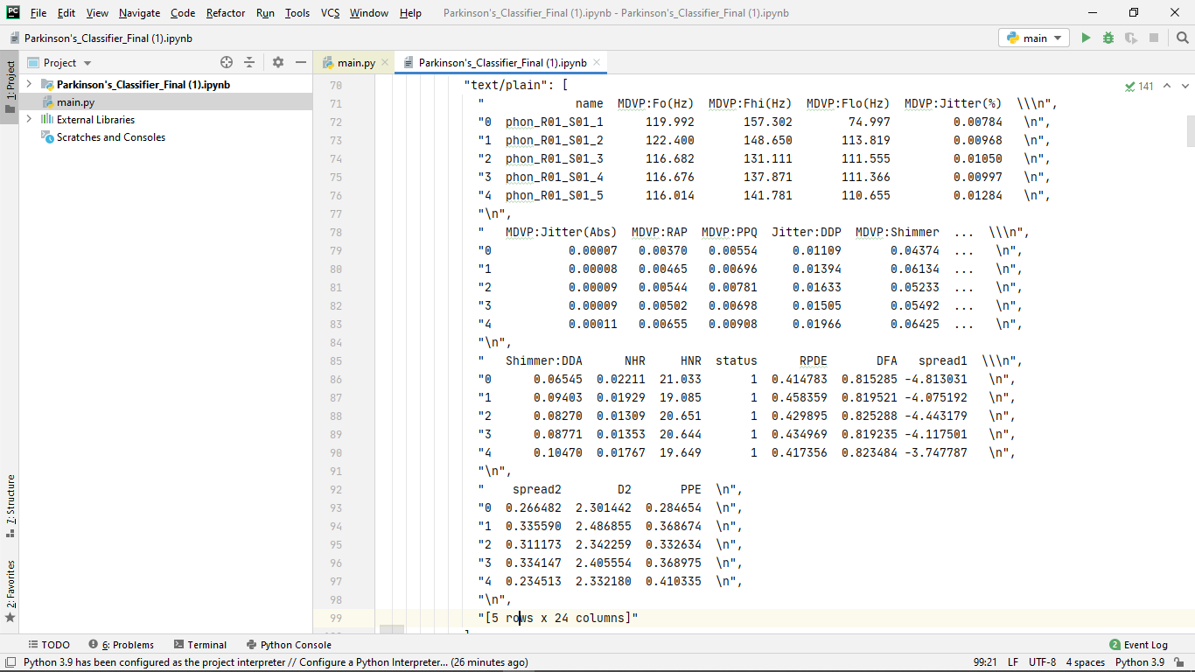
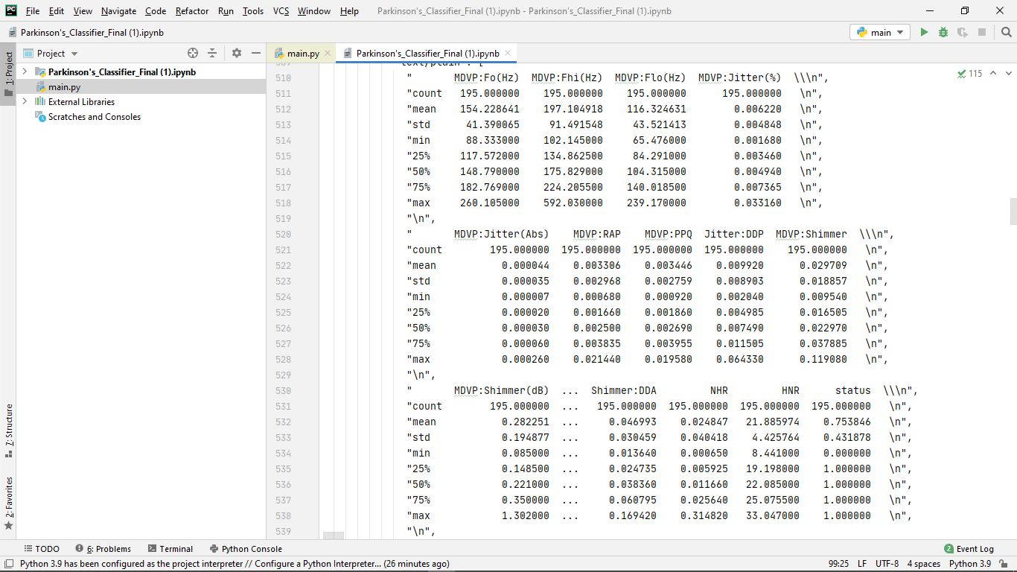

4.3 Software Architectural designs
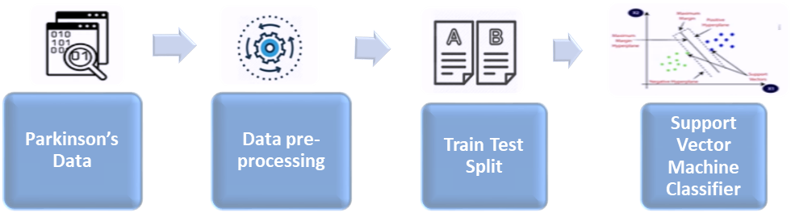
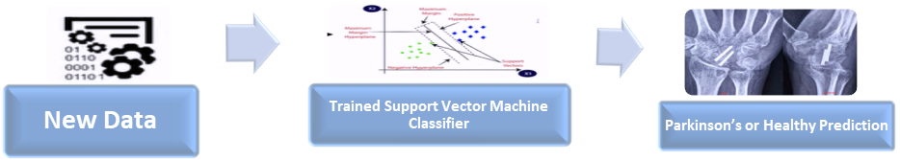
4.4 Summary
To summarize, we have processed the data and split it. We have used many algorithms, one of them was kNN to train the model for the successful prediction of Parkinson’s disease.
CHAPTER-5:
TECHNICAL IMPLEMENTATION & ANALYSIS

5.1 Outline
The below segment blankets will help you to know the implementation process in depth. Here step by step process involved is represented below:

1. Scientific Environment.
2. Source of a Data.
3. Excel 2016: the first process to store the data.
4. Loading data into jupyter notebook
5. Normalizing the data.
6. Detecting Outliers.
7. Analysis and visualization
8. Machine learning models are build using the various algorithm used for predictions as listed in the methodologies.
9. Splitting the data sets as test and train for the Cross-validation process.
10. Fitting the data into machine learning and data mining models for the Predictions.
11. Visualization.
5.2 Technical coding and code solutions

5.3 Working Layout of Forms
5.4 Prototype submission
5.5 Test and validation

5.6 Correlation Analysis:
Heat map :
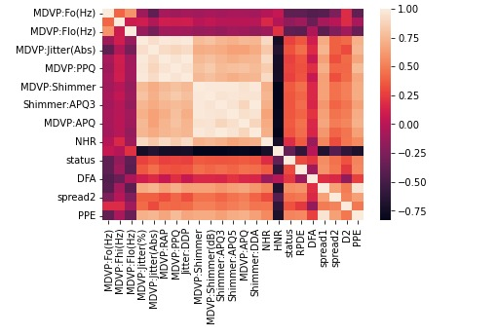
Correlation table :
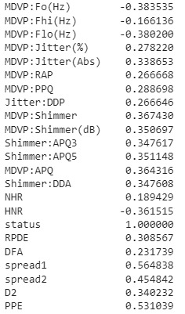

CHAPTER-6:
PROJECT OUTCOME AND APPLICABILITY
6.1 Outline
Disorders characteristics of Parkinson’s disease do not appear abruptly. It is a slow process whose first stages may go unnoticed. The extracted voice features(jitter, shimmer, HNR etc) from different participants contain many frames which take maximum processing time in the classification process, and prevent making correct diagnosis. After analytical process of KNN algorithm is carried our system predicts and display where the user has Parkinson or not.
6.2 key implementations outlines of the System
Pseudo code for KNN:
1) Load the data
2) Initialize the value of k
3)For getting the predicted class, iterate from 1 to total number of training data points
3.1) Calculate the distance between test data and each row of training data. Here we will use Euclidean distance as our distance metric since it’s the most popular method. The other metrics that can be used are Chebyshev, cosine, etc.
3.2) Sort the calculated distances in ascending order based on distance values
3.3) Get top k rows from the sorted array
3.4) Get the most frequent class of these rows
3.5) Return the predicted class

6.3 Significant project outcomes
Use of confusion matrix to analyses the performance of each algorithm.

Confusion Matrix:

Confusion matrix is a very popular measure used while solving classification problems. It can be applied to binary classification as well as for multiclass classification problems.

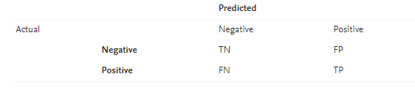

Confusion matrices represent counts from predicted and actual values. The output “TN” stands for True Negative which shows the number of negative examples classified accurately. Similarly, “TP” stands for True Positive which indicates the number of positive examples classified accurately. The term “FP” shows False Positive value, i.e., the number of actual negative examples classified as positive; and “FN” means a False Negative value which is the number of actual positive examples classified as negative. One of the most commonly used metrics while performing classification is accuracy. The accuracy of a model (through a confusion matrix) is calculated using the given formula below.

Accuracy = (TN+TP) ÷ (TN+FP+FN+TP)

Accuracy can be misleading if used with imbalanced datasets, and therefore there are other metrics based on confusion matrix which can be useful for evaluating performance. In Python, confusion matrix can be obtained using “confusion_matrix()” function which is a part of “sklearn” library [17]. This function can be imported into Python using “from sklearn.metrics import confusion_matrix.” To obtain confusion matrix, users need to provide actual values and predicted values to the function.

Research prefers that how many parameters is used in the performance analysis of classification algorithms. The confusion matrix is one among them. We have used this in performance comparison analysis of various people that may have parkinsons disease.

 | Predicted that person has disease | Predicted that person does not have disease
Person has disease | TP | FN
Person does not have disease | FP | TN

Correct Predictions = TP + TN
Incorrect Predictions = FP + FN

Evaluation of Result

S.no | Algorithms | Correct Predictions | Incorrect Predictions | Accuracy
1  2  3 | KNN  SVM  Random Forest | 37  34  34 | 2  5  5 | 94.87%  87.12%  87.17%

6.4 Project applicability on Real-world applications
With the help of this project, we can successfully determine whether the person has Parkinson’s disease or not. Building a model to accurately detect the presence of Parkinson’s disease in an individual.

CHAPTER-7:

CONCLUSIONS AND RECOMMENDATION
7.1 Outline
From the working of our model, we conclude that our accuracy is decent considering we used three algorithms to find the best one.
The root mean squared error is also low, the R2 value is decent and the adjusted R2 which takes the consideration of data attributes and number of entries is decent as well.

7.2 Limitation/Constraints of the System
Due to the lack of data, the current model enough to be deployed for real medical purposes.

7.3 Future Enhancements
As for future work, we will create a web-app to publish the model where we will try to collect more data and train the model for each data-frame. We will also incorporate some image processing-based symptoms analysis. For example, palm opening–closing and finger tapping can be analyzed from the video data captured by the same smartphone used for tremor and voice data collection. Also, the accelerometer sensor can be utilized for collecting the gait information during walking of the patient, and gait analysis may offer more reliability in PD detection.

7.4 Inference
The result obtained from combining the tremor and voice data in this work implies that this system can identify PD and its stage more reliably than a single-modality detection system. Besides, it can provide recommendations to the patients while updating the patient files with the latest disease progression stage. This collected database can be used upon their consent for population studies on the incidence of Parkinson’s, which are essential to scientists’ understanding of its history, progression, and risk factors. In this way, this system can help healthcare experts design strategies to meet patients’ needs, especially for rural areas where access to a neurologist is minimal.

REFERENCES
- https://www.researchgate.net/publication/357448942_THE_PARKINSON'S_DISEASE_DETECTION_USING_MACHINE_LEARNING_TECHNIQUES
- https://www.frontiersin.org/articles/633752
- https://www.nia.nih.gov/health/parkinsons-disease#:~:text=Parkinson's%20disease%20is%20a%20brain,have%20difficulty%20walking%20and%20talking.
- https://archive.ics.uci.edu/ml/datasets/parkinsons

